Course Selection in Fall semester of 2020 for Postgraduates in XJTU

After receiving the notice regarding the courses selection, all postgraduates should contact their supervisor to confirm his or her training plan, and login the Information Management system for Postgraduates to choose the courses on time. The system will be shut down after the course selections period ends. Please pay attention to the schedule.

1. Courses Selection

Course selection contains two steps. Step 1, design training plan; step 2, confirm class.

1. Design training plan.

Training plan refers to the plan for the whole studying years for each postgraduate based on his or her program, including the courses and all the compulsory parts.

* Design training plan online.

1. Time: 9:00 a.m., September 14, 2020---18:00p.m., September 18,2020
2. Procedures.

Login the Information Management system for Postgraduates

(http://gmis.xjtu.edu.cn)

Click “学生登录“，& activate your NetID with your student ID

Read the instruction for course selection

Check “all training plans applicable”

Check course list (containing brief introduction to the course and the lecturer)

Design the training plan under the guidance of the supervisor (Select compulsory courses first and then selective courses on the basis of the credit requirement of each module)

Submit the training plan to the Major school for further confirmation)

The online design of the training plan completed

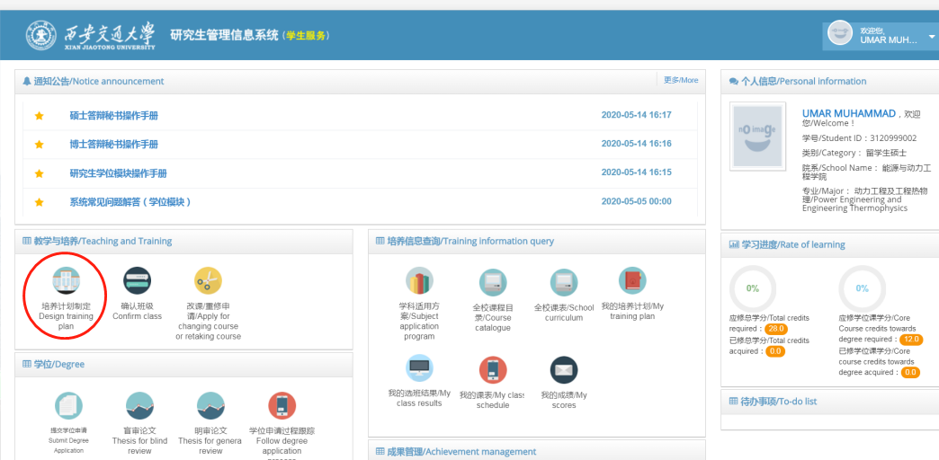

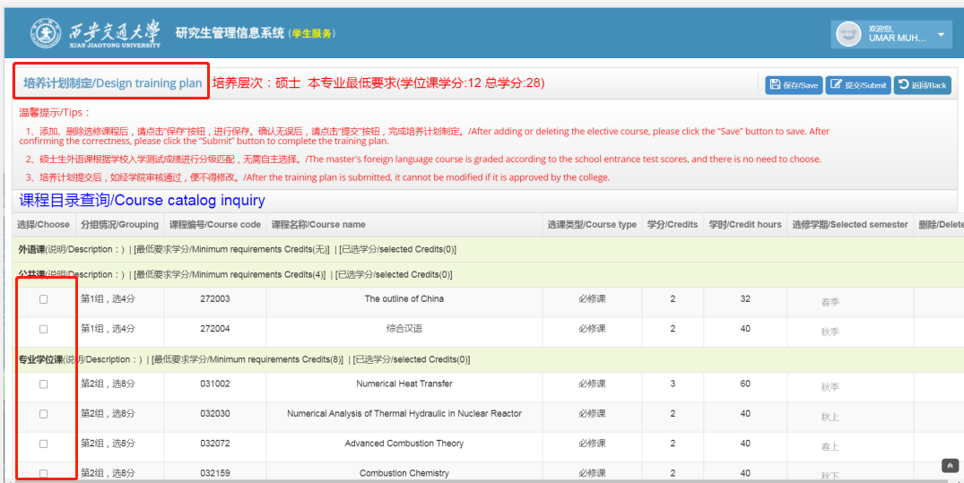

1. Notice:

Students must be under the instruction of the supervisor in designing the training plan. According to the requirement on the Discipline and Major in the Graduate Program for International Students (2020 version), students shall integrate their research fields with the plan,

1. Confirm class.

Class is fixed every semester. At the end of each semester, students confirm classes for the courses in the next semester. Once the class is confirmed, the time and place for the course is fixed.

* Confirm class

1. Time: 9:00 a.m., September 14, 2020---18:00p.m., September 18,2020
2. Procedures

Login the Information Management system for Postgraduates

(http://gmis.xjtu.edu.cn)

Click “个人信息” to check

Check”学习地点”

Click “确认班级” & choose “上课班级”

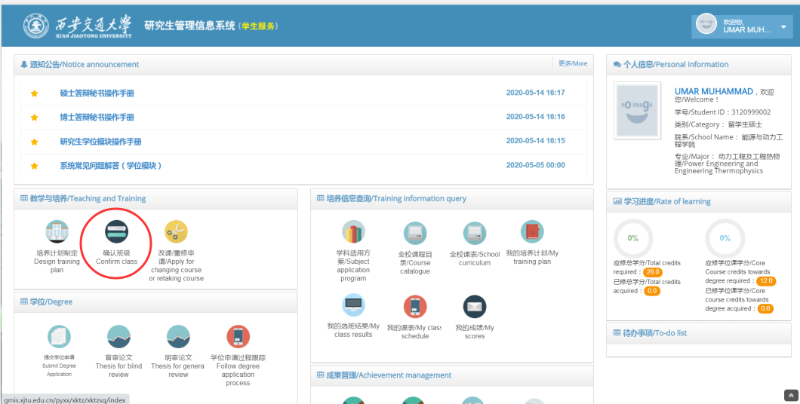

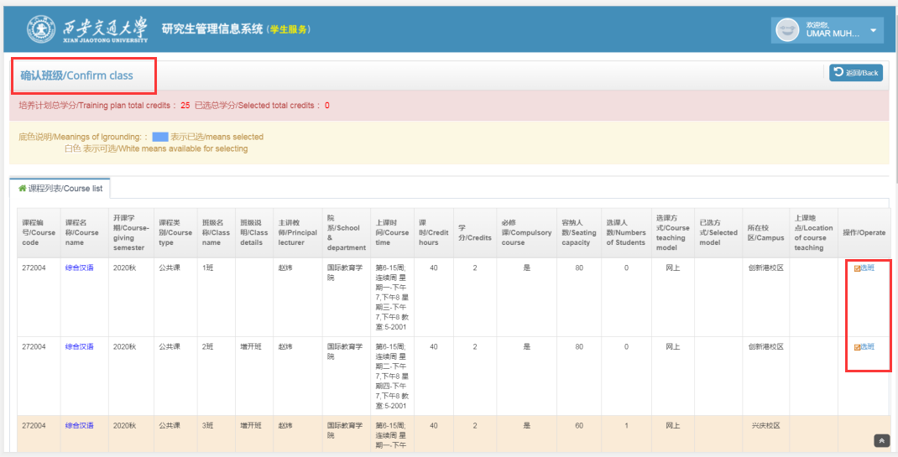

1. Notice:
2. There is a student number limit for each class. Early come, early served. If you fail to confirm the class, you can discuss with your supervisor to change your training plan.
3. The campus for each course is marked in the system. Principally, it will not change for the whole semester.
4. Course Adjustment

Course Adjustment means students can adjust their personal training plan or class which has been submitted in the information management system. Course Adjustment must meet the requirement of the training scheme of the student’s program. Supervisor’s approval is preliminary.

* Online course adjustment

1. Time: 9:00 a.m., September 21, 2020---18:00p.m., September 25,2020
2. Procedures:

Login the Information Management system for Postgraduates

(http://gmis.xjtu.edu.cn)

Click “改课/重修申请”

Adjust the class

Adjust training plan

Supervisor’s confirmation

Major school’s evaluation

1. Notice；
2. Please complete the adjustment in strict accordance with the open time of the system. The system will be shut down after the course adjustment period ends. Please pay attention to the schedule.
3. Course adjustment shall be conducted under the instruction of the supervisor. Students apply it in the information management system for postgraduates first, followed by the confirmation of the supervisor. Finally, the Major school evaluates the adjustment. The course adjustment is completed.
4. For the class adjustment, students can operate in the information management system directly. Neither the supervisor not the Major school will check or evaluate it.
5. If less than 10 students select a selective course, the course will be cancelled for the semester (except the courses is offered both in Iharbor and Xingqing campus). Please choose other courses during the course adjustment period.
6. S ave the training plan

After course adjustment, please print two copies of your training plan according to the requirement of your Major school. Bring the two copies to your supervisor and the teaching secretary for evaluation and signature. Submit one to the teaching secretary and keep one to yourself.

1. Others
2. Students should apply to both the Major school (Adjust the training plan) and the course school (Adjust the class) for adjustment within two weeks after the course starts. No adjustment application is accepted after two weeks (including change the course type).
3. Students shall attend the classes and exams according to the training plan and teaching plan.
4. Students should retake the courses if they fail in the exam. Courses you pass cannot be retaken.